Refreshments:
- Breakfast at God’s: Every Sunday from 8.30am – 9.30am in the Parish Hall. Do join us before the @9.15 service or after the 8am service for bacon and sausage rolls, toast, fruit juice and tea/coffee. It is a great opportunity to get to know one another.

Ways to keep up with the Minster online:
- www.beverleyminster.org.uk for news, service information, sermons and more. Sign up to the newsletter too: link on the homepage.
- Facebook: @BevMin1 for news, updates and livestreams
- Twitter: @Bev_Minster for news and events
- Instagram: @beverleyminsterofficial for pictures of what we’re up to
- YouTube: @BeverleyMinster1 for videos and livestreams
- Search for Beverley Minster on your podcast app for our weekly sermons

Contact Us:
Beverley Minster Parish Centre, 38 Highgate, Beverley, East Riding of Yorkshire, HU17 0DP.
- For general enquiries you can get in touch with us on our website at https://beverleyminster.org.uk/about-us/contact-us/.
- To contact the Administration Manager please email minster@beverleyminster.org.uk or ring 01482 868540 (Monday, Tuesday, Thursday and Friday).
- Parish Centre Hours: Monday, Tuesday and Thursday, 10am – 12noon.
- For pastoral concerns please contact the Vicar or Associate Vicar using the contact form on the website at https://beverleyminster.org.uk/about-us/contact-us/.

Volunteering at the Minster:
- Would you like to help with the children’s activities during our 11am service on a Sunday? We run groups for toddlers, primary school age children and teenagers and have gaps within all groups. If you are interested, please contact Ben Merrell at ben@beverleyminster.org.uk.
- Could you help serve teas and coffees at our wonderful baby and toddler groups? A chance to hang out in the kitchen and serve refreshments to the parents who attend. If you can help, please contact either Wendy at wendy@beverleyminster.org.uk or Ben at ben@beverleyminster.org.uk.
- Could you help with hosting, facilitating, welcoming or otherwise being involved with a discussion group looking at faith today? The idea is to create an environment particularly welcoming to those exploring faith for the first time. Times, frequency and content to be determined according to demand, but it would be good to have wide input. Contact the Vicar at vicar@beverleyminster.org.uk to find out more.

Volunteering in the Community:
- Open Doors is now “fully open” and many more Asylum Seekers and Refugees have started using the service. Unfortunately, many of the volunteers who used to help on a regular basis have not returned following the uncertainties of the Pandemic during the last 2 years. Open Doors is now looking to recruit new Volunteers and is specially in need of a Volunteer to work specifically with Refugees from Ukraine. More information may be obtained by contacting Open Doors directly- admn@open-doors.org.uk.

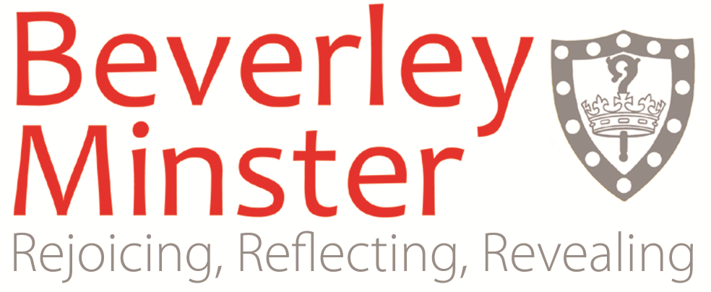
Sunday 3rd April 2022
Fifth Sunday of Lent

This Week at the Minster

Sun 3rd April
8am Holy Communion (BCP) in the Minster Quire
9.15am @9.15 Service in the Minster Nave
11am Choral Holy Communion (CW) in the Minster Nave
3.45pm The Crossing in the Parish Hall
5.30pm Choral Evensong in the Minster Nave
Around the Churches
9.15am Holy Communion (CW) at St Leonard’s, Molescroft
9.15am Holy Communion (CW) at All Saints’, Routh
10.30am Informal Service at the Church in Tickton

Mon 4th April
9.15am Staff Holy Communion in St Katherine’s Chapel

Tues 5th April
9.30am New Parents’ Group in the Parish Hall
9.30am Minster Primary Easter Service in the Minster
10.45am Time Out in the Parish Hall
11am Roof Tour in the Minster
2.15pm Mothers’ Union in the Peter Harrison Room

Wed 6th April
11am Ground Floor Tour in the Minster
3.30pm Oasis Youth Group in the Parish Hall
7.30pm Lent Course on Zoom

Thurs 7th April
10am Holy Communion (CW) in the Minster Quire
7.30pm Choral Evensong in the Minster Nave

Fri 8th April
12.30pm Spring Series Lunchtime Concert in the Minster

Sat 9th April
11am Ground Floor in the Minster
11am Roof Tour in the Minster
7.30pm Music for Passiontide in the Minster

Sun 10th April
8am Holy Communion (BCP) in the Minster Quire
9.15am @9.15 Service in the Minster Nave
11am Choral Holy Communion (CW) in the Minster Nave
3.45pm The Crossing in the Parish Hall
5.30pm Choral Evensong in the Minster Nave
Around the Churches
10.30am Holy Communion (CW) at St Peter’s, Woodmansey
10.45am Baptism Service at the Church in Tickton
3pm Evensong at St Leonard’s, Molescroft
Church Notices:

Revision of the Electoral Roll 2022: Over the next few weeks we are making an effort to update the Electoral Roll starting on 3rd April and ending on 24th April. This is an opportunity to remove names that no longer qualify, to update addresses and most importantly to enter new names on the Roll. There is a table in the north aisle with slips for deletions and address changes. There are forms for new enrolments.

Bread and Wine: From today we are reintroducing the sharing of wine by means of intinction. This means that instead of sharing a common cup, each wafer will be dipped in the chalice by the priest before being placed in the hands of the person receiving. This practice is now common in the Church of England and is another step towards restoring our former life.

Staff Eucharist: The monthly Staff Eucharist will restart next Monday. It will take place on the first Monday of the month at 9.15am in St Katherine’s chapel, will last about 30 minutes, and is open to all.

Coffee Time: It is wonderful to be able to enjoy coffee together again, and to see folk from both the main morning services coming together. Please bear in mind that our choir is also practising at this time before the 11am service; they will appreciate it if we can remember to keep noise levels down as much as we reasonably can.

Thinking of Hosting a Ukrainian Refugee? Several parishioners have mentioned that they are thinking of offering to open their homes to Ukrainian refugees. This may be something that the Minster could assist with as a Community Sponsor. Details of the Scheme and advice to help anyone considering this can be found at the following websites:

Church of England toolkit: https://www.churchofengland.org/resources/community-action/war-ukraine-responding
Government website: https://homesforukraine.campaign.gov.uk/
Sponsorship registration: https://www.homesforukraine.org.uk/
Sanctuary Foundation – one of the Government’s main partners: https://www.sanctuaryfoundation.org.uk/
Cinnamon Trust – website with good links: https://cinnamonconnect.co.uk/ukraine/

At present offers have to be matched with a named person from Ukraine; therefore, if anyone has contacts in Ukraine who might wish to come to the UK please let the Vicar know so that we can match sponsors.

Ukraine Humanitarian Campaign: All the major on the ground charities have now joined forces with the government. Your donations will be match funded and get direct to the places where it is needed. Find out more information and donate at https://www.dec.org.uk/appeal/ukraine-humanitarian-appeal.

Local Organisation Support: In April we are supporting Open Doors. A Christian Charity (Methodist Church, Princes Avenue, Hull, HU5 3QP) rooted and grounded in God's steadfast Love and Compassion for all of humanity, offers a warm welcome to Asylum Seekers and Refugees from all over the world fleeing persecution, torture, injustice and ravages of war irrespective of their race, religion, colour or creed. In addition to provision of essential items of living, Open Doors works together with specialist organisations such as Housing Associations, Community Integration and Advocacy Centre providing advice on Immigration Law and Red Cross helping trace relatives and providing detailed guidance for refugees. Open Doors are currently in need of tinned chickpeas, couscous, bulgur wheat, tahini, tomatoes, vegetable oil, tuna fish and rice, please avoid pork or ham-based products. They are also in need of any toiletries for men or women. Please put items for the foodbank in the box near the Minster shop.
Church Events:

Mothers’ Union: Beverley Minster Mother's Union will meet on Tuesday 5th April 2.15pm in the Peter Harrison room. This month's talk will be "Tales from the Beehive" by Wendy Maslin. We hope that there may be some jars of honey on sale. Do come and join us.

Lent Course 2022 “Seeing is Believing”: All are welcome to take part in this year’s Lent Meetings, which will follow last year’s series exploring the relationship between faith and films. Every Wednesday until 6th April at 7.30pm until 9pm on Zoom. Find out more information on the Beverley Minster website, https://beverleyminster.org.uk/lent-2022/.

Friday Lunchtime Concert: Our next Friday lunchtime concert is on Friday 8th April at 12.30pm, with Ronald Hawkes playing the organ. Refreshments, including soup, are available from 12noon. Do look out for further details of the programme for the year on our website. If you would like to be part of our team of people who steward and organised refreshments then please contact Robert Poyser music@beverleyminster.org.uk.

Music for Passiontide: Beautiful and contemplative choral masterworks for Lent and Easter with music from the 16th to 20th centuries, with reflections by the Archbishop of York, Stephen Cottrell. Saturday 9th April at 7.30pm. Tickets are £18 and more information can be found on our website, https://beverleyminster.org.uk/music-for-passiontide-2022/.

Christian Aid Lent Lunches: Next Sunday, 10th April at 12noon, the Lent Lunch will be at Norwood.

Upcoming Services:
- 10th April, Palm Sunday – the @9.15 service will be ‘Café Church’. Informal worship and discussion around tables with coffee and pastries. We hope to see you there.
- 17th April, Easter Sunday – there will be a joint morning service at 10.30am in the Minster.

Church in Tickton Easter Activities! The Church in Tickton is holding a Good Friday (15th April) activity afternoon from 2pm – 4pm at St Paul’s churchyard. The main activity will be Easter Garden-making and there will be an Easter trail. Booking will be necessary and information will be available soon. We are looking for church helpers to supplement the Tickton team and would particularly welcome those with links to Tickton school or village. Please contact Kate Powell on 01964 542189 or speak to Lauren (at the Parish Centre) on 01482 868540.

Vintage and Retro Fair: 23rd April, 10am – 4pm in the Minster. Antiques, handmade and upcycled. Book a stand by calling 01964 552470.

Renaissance Concert: John Law’s Renaissance concert is on Saturday 30th April at 8pm. Doors open at 7.30pm and tickets are £20.25 and can be purchased online from our website https://beverleyminster.org.uk/product/john-laws-renaissance/. It will be a fantastic opportunity to experience a night of beauty, meditation and mindfulness with music elements taken from jazz, minimalism and ambient chill.

